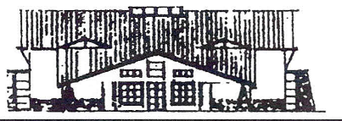

Public Notice:

Charleston Town Council Meeting Date for July
Has Been Moved Due to the July 4th Holiday

July’s Council Meeting Will be Held
July 3rd, 2019
7:00 pm
At
The Charleston Town Hall
3454 West 3400 South
Charleston, UT

