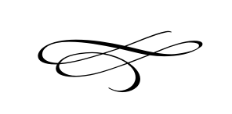
Charleston Planning Commission
Regular Meeting
March 26th, 2020
Cancelled
Charleston Town Hall
3454 West 3400 South, Charleston, Utah 84032

Meeting Cancelled
No Items to be addressed
Meeting Will Be Held Next Month

