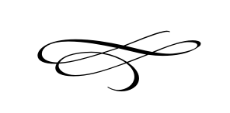
Charleston Town Council
Regular Meeting
Thursday – November 7th, 2019
7 p.m. – Town Hall

- Call to Order
- Pledge of Allegiance
- Opening Prayer
- Approval of Meeting Minutes for October 3rd, 2019 – Mayor Kozlowski
- Approval of Financials for October 2019 – Mayor Kozlowski
- Public Comment- This is the time and place for any person who wishes to comment on items not scheduled on the agenda for public hearing. Any person or group wishing to comment on any item not otherwise scheduled for public hearing on the agenda may address the Town Council at this point by standing and giving his or her name for the record. Comments should be limited to not more than three (3) minutes, unless additional time is authorized by the Town Council.

- Final Tax Rate Adoption Resolution #2019-13 – Mayor Kozlowski

- New Commercial Business License Application Submitted By Rex Sorensen – Brian Preece and Rex Sorensen

- Affordable Housing – Mayor Kozlowski

- Discussion And Update on Christmas Party And Employee Bonuses – Mayor Kozlowski

- December Meeting Change – Mayor Kozlowski

- Park Equipment, Update From Possible Grant Meeting – Darrel Nish

- Staff Reports:

- Adjournment:

