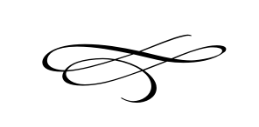
Charleston Town Board
Truth In Taxation Public Hearing
Wednesday – August 14th, 2019
7 p.m. – Town Hall

- Call to Order

- Pledge of Allegiance

- Opening Prayer

- Truth In Taxation Public Hearing to Hear Comments on Proposed Property Tax Increase

- Adjournment:

