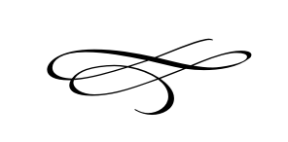
Charleston Town Board
Regular Meeting
Thursday – August 1st, 2019
7 p.m. – Town Hall

- Call to Order
- Pledge of Allegiance
- Opening Prayer
- Approval of Meeting Minutes for July 3rd, 2019 – Mayor Kozlowski

- Approval of Financials for July 2019 – Mayor Kozlowski

- Public Comment- This is the time and place for any person who wishes to comment on items not scheduled on the agenda for public hearing. Any person or group wishing to comment on any item not otherwise scheduled for public hearing on the agenda may address the Town Board at this point by standing and giving his or her name for the record. Comments should be limited to not more than three (3) minutes, unless additional time is authorized by the Town Board.

- Public Hearing – A public hearing to receive input from the public regarding the Towns’ intention to create or designate Special Assessment Area No. 2019-01(Winterton Farms) for road improvements.

- General Plan Discussion – Mayor Kozlowski

- Pioneer Day Celebration Report – Vaughn Rasband/ Darrel Nish

- Staff Reports:

- Adjournment:

