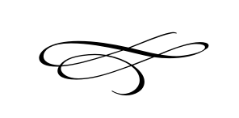
Charleston Town Board
Regular Meeting
Wednesday – July 3rd, 2019
7 p.m. – Town Hall

- Call to Order
- Pledge of Allegiance
- Opening Prayer
- Approval of Meeting Minutes for June 6th, 2019 – Mayor Kozlowski
- Approval of Financials for June 2019 – Mayor Kozlowski

- Public Comment- This is the time and place for any person who wishes to comment on items not scheduled on the agenda for public hearing. Any person or group wishing to comment on any item not otherwise scheduled for public hearing on the agenda may address the Town Board at this point by standing and giving his or her name for the record. Comments should be limited to not more than three (3) minutes, unless additional time is authorized by the Town Board.

- Decision on Ordinance # 2019-02 Charleston Town Council Repealing Premises Occupation Within the Land Use Ordinance (Public Hearing Previously Held May 2, 2019) – Mayor Kozlowski

- Discussion on Impact Fee – Mike Smith

- General Plan Discussion – Mayor Kozlowski

- Pioneer Day Celebration- Events Committee Report on Progress – Events Committee

- Staff Reports:

- Adjournment:

