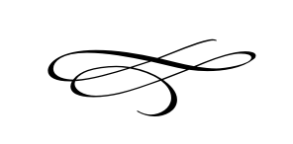

**Charleston Planning Commission**

**Regular Meeting**

**April 25th, 2019**

**7:00 pm**

Charleston Town Hall

3454 West 3400 South, Charleston, Utah 84032

1. **Call to Order**
2. **Opening Prayer**
3. **Pledge of Allegiance**
4. **Approval of Minutes For March 28, 2019 Meeting**
5. **Public Comment**- This is the time and place for any person who wishes to comment on items not scheduled on the agenda for public hearing. Any person or group wishing to comment on any item not otherwise scheduled for public hearing on the agenda may address the Town Board at this point by standing and giving his or her name for the record. Comments should be limited to not more than three (3) minutes, unless additional time is authorized by the governing body.
6. **Section 02.90632 Land Use Ordinance, Premises Occupation Discussion and Recommendation To Town Council for Action (Public Hearing Previously held February 28th 2019) –** Members
7. **Final Application for Summit Creek Subdivision Review and Recommendation To The Town Council** – Blake Howell
8. **Premises Occupation Application Nott-Hill Investment Corp.** – David & Lynn Hill

IV. **Adjournment**