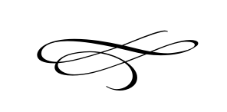

**Charleston Planning Commission**

**Regular Meeting**

**February 28th, 2019**

7:00 pm

1. **Call to Order**
2. **Opening Prayer**
3. **Approval of Meeting Minutes For January 2019**
4. **Public Comment:** For comments from the public on items not scheduled for a  
   Public Hearing on tonight’s agenda.
5. **Ordinance 2019-02:** Request of the Town Board for a recommendation from the Planning Commission on the potential the repeal of the Premises Occupation provisions from Section 02.0632 of the Charleston Town Land Use Ordinance:
   1. **Presentation by Staff—**Brian Preece.
   2. **Public Hearing on Proposed Ordinance.**
   3. **Discussion—**Planning Commission Members.
   4. **Potential Action by the Planning Commission Regarding   
      a Recommendation to the Town Board on Proposed Ordinance 2019-02.**

IV. **Adjournment**