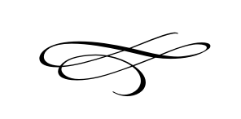

**Charleston Planning Commission**

**Regular Meeting**

**June 27th, 2019**

**7:00 pm**

Charleston Town Hall

3454 West 3400 South, Charleston, Utah 84032

1. **Call to Order**
2. **Opening Prayer**
3. **Pledge of Allegiance**
4. **Approval of Meeting Minutes For April 25, 2019**
5. **Public Comment**- This is the time and place for any person who wishes to comment on items not scheduled on the agenda for public hearing. Any person or group wishing to comment on any item not otherwise scheduled for public hearing on the agenda may address the Town Board at this point by standing and giving his or her name for the record. Comments should be limited to not more than three (3) minutes, unless additional time is authorized by the governing body.
6. **Public Hearing-Premises Occupation Application Nott-Hill Investment Corp. 3191 South 2900 West Charleston, Utah (2nd Application)** – David & Lynn Hill
7. **Concept Subdivision Application Located at Approximately 2701 West 2400 South Owned by Jim and Carrie May** – Jeff Findarle
8. **Concept Subdivision Application Located at 3058 South 3600 West Owned by Mikel and Nanette Chertudi** – Mikel Chertudi

IV. **Adjournment**