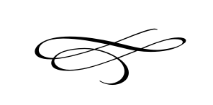

**Charleston Land Use Appeal Authority**

**Meeting Agenda**

**August 28th, 2019**

**7:00 pm**

Charleston Town Hall

3454 West 3400 South, Charleston, Utah 84032

1. **Call to Order**
2. **Appointment of Land Use Board President**
3. **Opening Prayer**
4. **Pledge of Allegiance**
5. **David & Lynn Hill, Request for Variance Application – Seeking to Build A Barn\Residence on Property Without Sufficient Frontage Located 3205 South Probst Lane – Charleston - Utah**
6. **Open Meetings Training – Brian Preece**

VIII. **Adjournment**