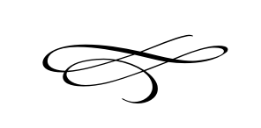

**Charleston Town Council**

**Meeting**

**Thursday – November 1st, 2018**

**7 p.m. – Town Hall**

1. **Call to Order**
2. **Pledge of Allegiance**
3. **Opening Prayer**
4. **Approval Meeting Minutes October 2018** – Mayor Kozlowski
5. **Approval Monthly Financials October 2018**- Mayor Kozlowski
6. **Public Comment**:
7. **Soldier Hollow School Signs** – Morgan Murdock
8. **Soldier Hollow Rental Schedule -** Morgan Murdock
9. **Premises Occupation Ordinance Report on Prior Findings** – Clerk
10. **Town Christmas Party** –Mayor Kozlowski
11. **Officials Thank You Party (January)** – Mayor Kozlowski
12. **Highest Bids On Surplus Picnic Tables** –Mayor Kozlowski
13. **Employee Bonuses and Pay Raises** – Mayor Kozlowski
14. **Staff Reports**:
15. **Adjournment**