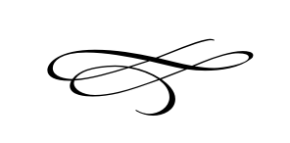

**Charleston Town Council**

**Meeting**

**Thursday – October 4th, 2018**

**7 p.m. – Town Hall**

1. **Call to Order**
2. **Pledge of Allegiance**
3. **Opening Prayer**
4. **Approval Meeting Minutes September 2018** – Mayor Kozlowski
5. **Approval Monthly Financials September 2018**- Mayor Kozlowski
6. **Public Comment**:
7. **Soldier Hollow School** – Morgan Murdock
8. **Town Hall Use for The Midway Quilters**- Mayor Kozlowski
9. **New Zealand Basketball Team Using The Town Hall**- Mayor Kozlowski
10. **Wells Fargo And Fraud Protection** – Mayor Kozlowski
11. **Premises Occupations and Possible Discontinuing**- Vaughn Rasband *****Amended Item Below****

**Resolution# 2018-13 Amending The Enterprise Zone**

1. **Pumpkin Contest** – Mayor Kozlowski
2. **Christmas Party** – Mayor Kozlowski
3. **Staff Reports**:
4. **Adjournment**