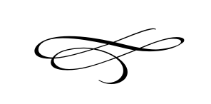

**Charleston Town Board**

**Meeting**

**Thursday – June 7th, 2018**

**7 p.m. – Town Hall**

1. **Call to Order**
2. **Pledge of Allegiance**
3. **Opening Prayer – Rajan Zed**
4. **Approval Meeting Minutes May 2018** – Mayor Kozlowski
5. **Approval Monthly Financials May 2018**- Mayor Kozlowski
6. **Public Comment**:
7. **Public Hearing for Amended Budget 2018**- Public
8. **Approval of Amended Budget 2018** – Mayor Kozlowski
9. **Public Hearing for the Tentative Budget for 2019** – Public
10. **Approval of Tentative Budget for 2019** – Mayor Kozlowski
11. **Resolution #2018-08 Annual Tax Rate Acceptance**
12. **Resolution #2018-09 PTIF Account**
13. **Utah Division of Forestry, Fire and State Lands Agreement** – Mayor Kozlowski
14. **Roads Discussion** – Vaughn Rasband
15. **Strong Vertical Gardens Request for Enterprise Classification** – Discussion only
16. **School Signs** – Mayor Kozlowski
17. **September Meeting Schedule** – Mayor Kozlowski
18. **Staff Reports**:
19. **Adjournment**