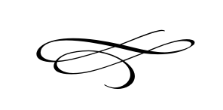

**Charleston Town Board**

**Meeting**

**Thursday – February 1st, 2018**

**7 p.m. – Town Hall**

1. Call to Order
2. Pledge of Allegiance
3. Opening Prayer
4. Meeting Minutes and Financials for January 2018 – Mayor Kozlowski
5. Heber Light & Power Board Resolution #2018-05 – Mayor Kozlowski
6. Resolution #2018-06 Mayor Pro Tem – Mayor Kozlowski
7. Open Meetings Discussion & Training – Mayor Kozlowski\Clerk
8. Attendance for ULCT Seminar in April - Clerk
9. Treasurer Bond Increase – Mayor Kozlowski\Clerk
10. Commercial Business License increase – Mayor Kozlowski\Clerk
11. Discussion regarding clerk & Notary certification Mayor Kozlowski\Clerk
12. Finance Practices – Mike Smith
13. Discussion about Town Attorney and availability – Mayor Kozlowski
14. Staff Reports
15. Adjournment

\*\*\*\*\***Executive Session If Needed\*\*\*\*\***