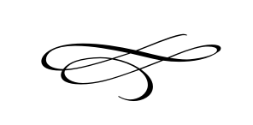

Charleston Planning Commission

Regular Meeting

September 27th, 2018

**No Meeting This Month**