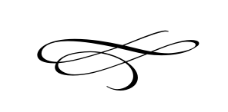

Charleston Planning Commission

Regular Meeting

August 23rd, 2018

**Meeting Cancelled Lack of Agenda Items**