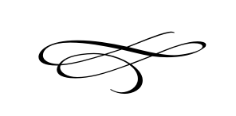

Charleston Planning Commission

Regular Meeting

April 25th, 2018

Regular Meeting

1. Call to Order
2. Opening Prayer
3. Review & Approval of Meeting Minutes March - 2018
4. **Ronald Reiland Flag Lot Subdivision Application Concept**- Ron Reiland
5. **Resolution PC 2018-01 Planning Commission Policies & Procedures** – Brian Preece
6. Adjournment