Attachment “A”
Town of Charleston Revised
Fee Schedule.
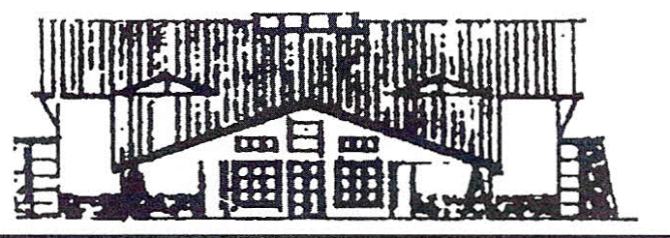 Charleston Town Fee Schedule
Revised July 2021

Annexation: $1000.00 plus any actual expenses incurred by the town above this amount e.g. (Legal, Inspection Fees, Engineering, Mailing Expenses for public hearing etc.)

Hearing Officer: All Legal Fee from the Town Appointed Hearing Officer and

any Engineering fees incurred

Business License

Residential License New $50 Renewal $50.00
Commercial License New $100 Plus $75 Fire Inspection Renewal $50 + $75 Annual Fire Inspection Fee

Cemetery: Resident Non-Resident
List of Burials $ 25.00 $ 25.00
Plot Transfers $ 25.00 $ 25.00
Burial - Weekdays $600.00 $1,200.00
Sat. & Holiday $800.00 $1,400.00
Lot Purchase $500.00 $2,000.00
Cremation & Infants $250.00 $350.00
Sat. & Holiday $350.00 $450.00
Disinterment $1,200.00 $1,400.00

Copies –- $.25 per page
With GRAMA Request
Cemetery List of Burials $25.00
Annexation Law $10.00
Map (Annex and Zoning $10.00
Nuisance Ordinance $ 5.00
Sign Ordinance $ 5.00

Subdivision Ordinance $15.00
Land Use Ordinance: $20.00
With Nuisance Ord. $25.00
With Sign Ord. $25.00
With Nuis. and Sign $30.00

Permit for Excavation within a Town Right-of-Way: $1000.00 (Inspection Fees that exceed

Set Amount)

Sign Permit $25.00 per sign

Subdivision Approval:
Concept $300.00 Plus All Legal & Engineering fees incurred
Preliminary $1000.00 + $50.00 per lot Plus All Legal & Engineering fees incurred
Final $750.00 + $50.00 per lot Plus All Legal, Inspection Fees & Engineering
fees incurred
Site Plan Approvals $500 + Legal, Engineering & Inspection Fees

Zoning (Land Use):
Zoning Compliance Letter $250.00
New Zone Creation $1,000.00 + All Legal Fees Incurred
Zone Change $350.00 + All Legal Fees Incurred
Land Use Ordinance Change $350.00 + All Legal Fees Incurred

Park & Town Hall Rental

Park: Deposit - $200.00

Park &Pavilion Resident Non-Resident
Regular Holiday Regular Holiday
1 to 4 hours $ 50.00 $100.00 $500.00 $600.00 ($100 per additional hr.)
4 to 8 hours $100.00 $200.00 $1,000.00 $1200.00 ($100 per additional hr.)

10pm maximum time limit

Resident Non-Resident
Town Hall Use: Deposit: $200.00 $500.00
Resident Non-resident (Town Resident Sponsor Required)

Reception/Ceremony $400.00 $1000.00

Activities in Gym Regular Holiday Regular Holiday
Up to 4 hours $ 50.00 $100.00 $200.00 $300.00($100 per additional hr.)
4 to 8 hours $100.00 $200.00 $400.00 $600.00($100 per additional hr.)

10pm maximum time limit

Meeting (Board Room)
Up to 4 hours $ 25.00 $50.00
4 to 8 hours $ 50.00 $80.00

10pm maximum time limit

